How to search for special characters in Excel

In Excel, special characters refer to any character that is not a letter, number, or typical punctuation mark. These characters often have specific functions or meanings within Excel formulas, data formatting, or other operations.

This dataset contains information about individuals' IDs, names, occupations, and salaries. It includes names with special characters from various languages and scripts, such as diacritics, non-Latin characters, and symbols, adding linguistic and cultural diversity to the dataset. In this tutorial, we will learn how to highlight the cells containing special characters making it easier to search for special characters.

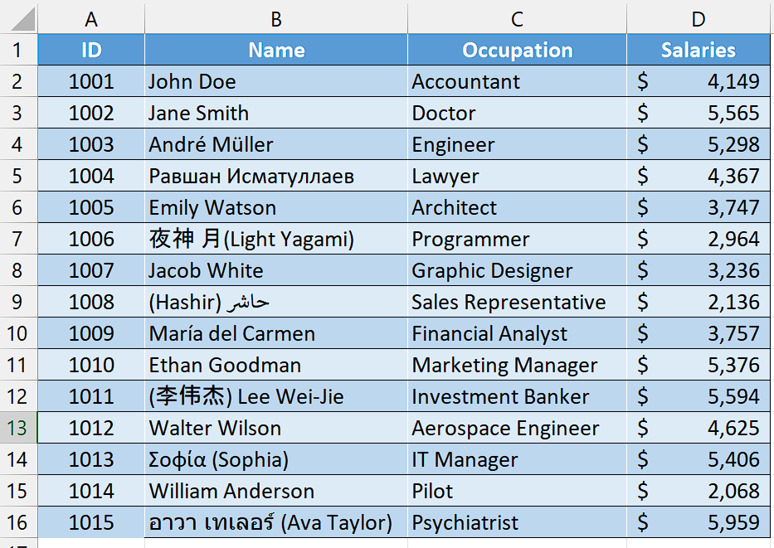

## Step 1 – Add a module

* For adding a module, navigate to Developer tab.
* After that, click on the first option named as Visual Basic.
* You’ll see a new window on your screen and you can also open this window by using shortcut key (Alt+F11) as well.
* Then, click on the Insert tab in this window and click on the Module option.
* Now, a new module would open.



## Step 2 – Write the code

* Now, write the following code in the module

Sub Highlight_SPC_CHAR()

Dim rng As Range

Dim cell As Range

Set rng = ActiveSheet.UsedRange ' Change to the desired sheet

For Each cell In rng

If ContainsSpecialCharacters(cell.Value) Then

cell.Interior.Color = RGB(0, 100, 100) ' Change the color as desired

cell.Font.Color = RGB(255, 255, 255)

End If

Next cell

End Sub

Function ContainsSpecialCharacters(str As String) As Boolean

Dim i As Long

For i = 1 To Len(str)

ch = Mid(str, i, 1)

Select Case ch

Case "0" To "9", "A" To "Z", "a" To "z", " "

' Continue checking

Case Else

ContainsSpecialCharacters = True

Exit Function

End Select

Next i

ContainsSpecialCharacters = False

End Function

* Then, close the VBA Editor by using “Alt+Q” shortcut key.



## Step 3 – Run the macro

* Use “Alt+F8” key to open the “Run a macro” dialogue box.
* Then, click on the macro named “Highlight_SPC_CHAR”.
* After doing that, click on “Run” button and all the cells containing special characters will be highlighted.

